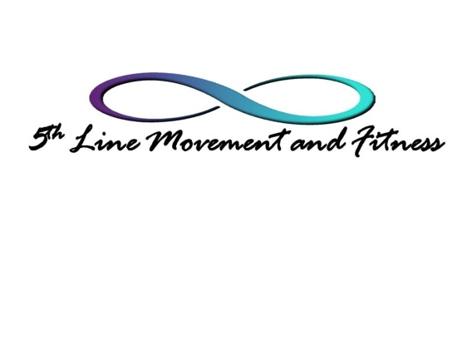
Please print, complete and send form to the following email: info@5thlinemovementandfitness.com

I give 5th Line Movement and Fitness permission to use photos and/or videos of me in this studio on social media for marketing purposes. I understand that currently, 5th Line Movement and Fitness is only using their website, Facebook, Yelp and Google for marketing and that should another social media platform be utilized in the future I will be notified and asked permission to be used on that/those platforms.
(initial) I also give 5th Line Movement and Fitness permission to use photos of me in the studio on printed marketing materials such as flyers and brochures.
Permission to do so will remain in effect indefinitely or until I request my image no longer be used.

Printed Name Signature Date

