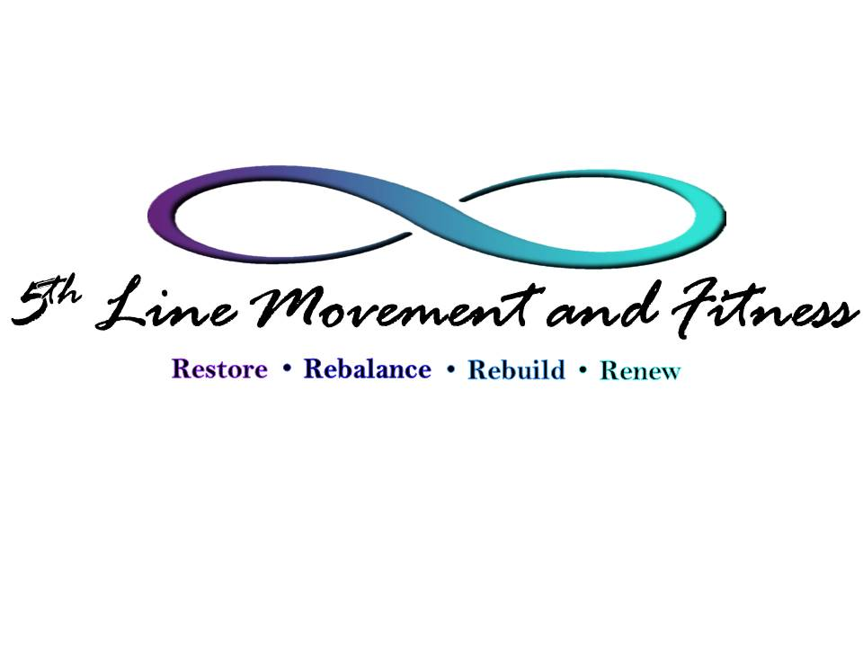
COVID19 Policy and Procedures
As we all continue to deal with the current COVID19 epidemic, we will be implementing the following studio policies and procedures to support your health and safety once we are able to open in our new downtown location. These policies and procedures all meet and exceed Center for Disease Control guidelines.

Number of People Allowed In the Studio At Once
We will only be allowing 4 individuals, inclusive of instructors, to be in the studio at the same time. If the studio is being shared, we will maintain as much distance between each staff / client pair as possible. We ask that you arrive no earlier than 5 min. prior to your session as we have no waiting room. Upon arrival, please call the studio at 210-464-3868 to advise us you are outside waiting and we will call you back to let you know when the studio is ready for you to enter.

Masks
We ask that you wear a mask upon entering the studio and keep it on until you are on your equipment and able to be 6 feet apart from anyone next to you. At that point we will leave it up to you whether you would like to continue to wear your mask or proceed without it. We are supportive of your choice either way according to your own comfort level. Instructors will wear masks as clients arrive and depart as appropriate social distancing cannot be maintained during those times. At the end of your session or class, before leaving your equipment, we will ask you to once again put on your mask until you have exited the studio.

Restroom Facilities
We do have a restroom available if needed; however, because of its location, we ask you to please use the restroom prior to coming to the studio if possible. We also do not have changing rooms available right now, so please be sure to show up wearing the clothes you intend to workout in. Please see FAQ section on our website under the “Studio” tab in the menu at the top of the web page for appropriate clothing and prohibited clothing.

Equipment and Studio Sanitization
At the beginning of each day the studio floor tile, light switches, door handles and large equipment will be wiped down with an alcohol sanitizing solution. The carpeted portion of the studio will be vacuumed at the start of each day. Throughout the day, any equipment that is used during an appointment will be wiped down with warm soap and water on the wood and with the alcohol sanitizing solution on non-wooden parts in between each client. Fabric straps will be cleaned in a UV Light Sanitization Unit in between classes and private sessions. When your session or class begins, you will be handed a set of sanitized straps and they will only be used by you and you alone throughout the duration of your session or class. Any small equipment used during the course of an appointment or session will be sanitized prior to and after each use with an alcohol sanitizing solution.

Personal Effects
Please bring only the minimal personal items necessary into the studio with you. Upon your arrival, we ask you immediately remove your shoes (and socks, if applicable) and place them on the tile near the door, and to place all other personal items not needed during your session or class in one of the purple baskets provided

Hand and Feet Sanitization
As previously stated, you will be asked to remove your shoes and socks immediately upon entering the studio and put them on the tile near the door and place any other belongings in the purple baskets. Once you have done so, we will have you sanitize your hands and feet -- either with an alcohol mixture which will be provided, or if you would prefer, your own hand sanitizing gel or wipes.

Gloves and Socks
Although the equipment is sanitized between each class and client, if you are not comfortable touching the equipment with your bare hands you may request a pair of our light weight, knit gloves which have been UV light sanitized. You may bring your own pair of freshly washed gloves to wear if you wish, however you will not be permitted to wear latex or nitrile gloves as they cause the hands to sweat too much.
GYROTONIC® and GYROKINESIS® Methods of exercise as well as Pilates exercises are most often performed barefooted in order for the client to receive the best biomechanical feedback. However, if you would prefer to wear socks we encourage you to do so according to your own comfort level as long as they are socks that are clean and were not worn into the studio. We recommend socks that have sleeves for each toe (similar to gloves for the hand). For Gyrotonic sessions as well as Pilates sessions we advise socks that also have non-skid applications on the bottom as our floors are wood and without the non-skid applications your feet will tend to slide making the exercises difficult. For Gyrokinesis classes, on the other hand, socks without non-skid bottoms are better as you will need to have your feet slide during the matwork portion of the class.

I, , have read, understand and agree to comply with the
(Client’s Full, Printed Name)
above stated policy and procedures.

Client Signature Date

